**Ideation Phase**

**Define the Problem Statements**

|  |  |
| --- | --- |
| Date | 25 June 2025 |
| Team ID | LTVIP2025TMID36909 |
| Project Name | TrafficTelligence Advanced Traffic Volume Estimation With Machine Learning |
| Maximum Marks | 2 Marks |

**Customer Problem Statement Template:**

Create a problem statement to understand your customer's point of view. The Customer Problem Statement template helps you focus on what matters to create experiences people will love.

|  |  |  |  |  |  |
| --- | --- | --- | --- | --- | --- |
| **Problem**  **Statement (PS)** | **I am**  **(Customer)** | **I’m trying to** | **But** | **Because** | **Which makes me feel** |
| PS-1 | A city traffic  manageme  nt authority or smart city planner | Efficiently monitor and  manage  traffic  volume across multiple | Current traffic  monitorin g systems are either outdated, expensive | There is no dynamic or real-time traffic  adjustment system in place | Anxious, frustrated, and dissatisfied with the overall urban transportation experience |

A well-articulated customer problem statement allows you and your team to find the ideal solution for the challenges your customers face. Throughout the process, you’ll also be able to empathize with your customers, which helps you better understand how they perceive your product or service.

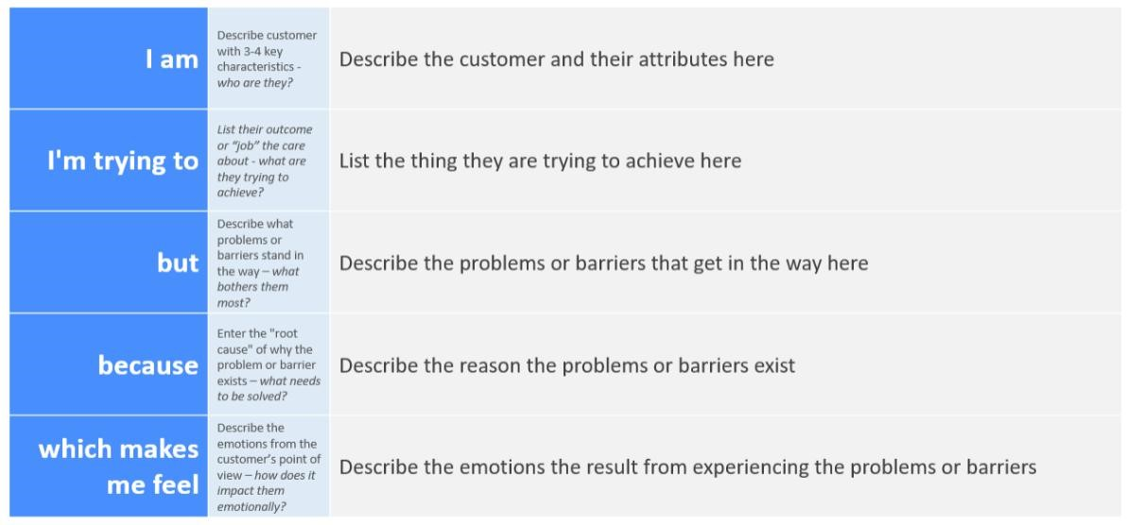

Reference: <https://miro.com/templates/customer-problem-statement/>

**Example:**

|  |  |  |  |  |  |
| --- | --- | --- | --- | --- | --- |
|  |  | urban junctions in real time | to maintain, or require manual interventi ons which lead to errors and delay |  |  |
| PS-2 | A daily  commuter  in a busy metropolita n area | Reach my destination on time without delays or unpredictabl e congestion | often get stuck in traffic due to poor signal timing and lack of traffic  volume  awarenes  s | There is no dynamic or real-time traffic  adjustment system in place | Anxious, frustrated, and dissatisfied with the overall urban transportation experience |